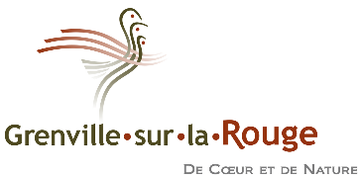
Mayor’s word - regular meeting of the municipal council of October 5, 2021
Last session of the municipal council elected on November 5, 2017
Hello everybody,
Today’s municipal council meeting is a special day because it is the conclusion of 4 years of hard work to improve the quality of life of our citizens of Grenville-sur-la-Rouge.
I would like to thank the team of 6 councillors, first Ron Moran and Serge Bourbonnais, who worked hard for more than 3 years, but who had to leave for personal reasons. Also Manon Jutras, Natalia Czarnecka, Denis Fillion and Marc André Le Gris, who worked tirelessly to accomplish whatever needed to be done. Councillors are very committed to making the best possible decisions to support the community. It’s hard work that deserves great respect.
I would also like to thank you our General Manager Marc Beaulieu, and the whole team around him. It is a lot because of them and the quality of their work that we can get all the work done. I and the council are so grateful that we can count on them.
Finally, I want to thank the citizens of Grenville-sur-la-Rouge who trusted us during the vote on November 5, 2017, 4 years ago.
There was a lot to be done, and I believe significant progress has been made:
- The reorganization of the municipal administration and public works
- Improving infrastructure, including roads, culverts and buildings
- The launch of the Chutes de la Rouge campground, which brings in significant income
- The Canada Carbon graphite mine file, where it is important that citizens' rights and the environment be respected
- The sound administration of our financial and material resources to achieve maximum value for the community, with the help of the team in place
- I also want to underline the improvement of communications with citizens. I believe that our municipal meetings like today are being held with a lot of respect, better than ever
There are a lot of other improvements that have been made, and there is still a lot of work to come.
The municipality has experienced special events, such as the spring 2019 floods, the evacuation due to the Bell Falls dam, and the chronic wasting disease that affected the deers. We are also living in difficult times due to Covid-19.
We will be back to continue the work for the next 4 years. I want to greet the 3 people present who are the new councillors for the next 4 years, namely Isabelle Brisson, Patrice Deslongchamps and Carl Woodbury.
The next regular meeting of the municipal council will take place on Tuesday, November 9th.

