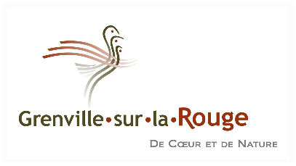
PRESS RELEASE
For immediate release
Grenville-sur-la-Rouge lacks information
to issue a notice of compliance to
Canada Carbon’s recent application to the CPTAQ

Grenville-sur-la-Rouge, May 2, 2023 - On March 20, 2011, the mining exploration company Canada Carbon filed a new application with the Commission de Protection du territoire Agricole du Québec (CPTAQ) to obtain permission for non-agricultural use as a first step in the process of economic feasibility analyses of a graphite mine.
The Agricultural Land and Activities Protection Act (TAPA) requires the municipality to notify the CPTAQ of the application’s compliance with its zoning by-law. However, some projects may prevent the application of the municipality’s zoning regulations as provided for in section 246 of the Planning and Development Act (UDA). For this reason, and subject to obtaining certain information from Canada Carbon that would allow the municipality to review its position, the municipality will not issue a notice of compliance on Canada Carbon’s recent application to the CPTAQ regarding its graphite mine project.
“The municipality shares the views of the Union des Municipalités du Québec (UMQ), the Fédération des Municipalités du Québec (FQM) and hundreds of municipalities that are calling for the abolition of section 246 of the UDA, in order to allow us, as a local government, to plan and manage our territories with a sustainable development perspective. Exploration and mining can have their place if they respect the community’s objectives in terms of environment, of land use planning, of quality of life of citizens and of preservation of natural environments and biodiversity," said Mayor Tom Arnold.
However, the municipality passed a resolution asking the CPTAQ to refuse Canada Carbon’s request.
In 2021, the independent experts appointed by the municipality, an agronomist, a forest engineer and a hydrogeologist, raised some real issues about the project, which the CPTAQ recognized. This is one of the reasons why the CPTAQ refused Canada Carbon’s application to operate a graphite mine and marble quarry in 2021.
Canada Carbon’s new application reveals problems that must lead to its refusal by the CPTAQ. In particular, the municipality is of the opinion that the application is only an application for the completion of additional studies, but does not specify in any way the studies that Canada Carbon Inc. wishes to conduct, or how or why they are necessary. The application is also too imprecise and incomplete to be authorized.
The municipality is also of the opinion that the Canada Carbon project ignores the characteristics of the environment and threatens its sustainability, raises concerns about some wells supplying nearby residences and is potentially harmful to the preservation of water and soil resources needed for agricultural activities and the protection of maples.
"The municipality will continue to play its role in protecting the interests of its citizens and their environment," concluded Mayor Tom Arnold.
– 30 –
For information :
Tom Arnold, mayor of the municipality of Grenville-sur-la-Rouge, 613-677-1001

