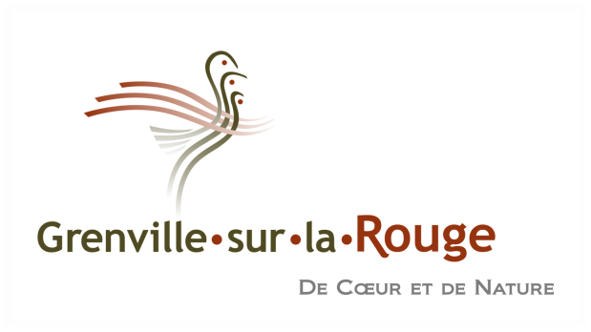

Issued: Monday, October 25, 2021

IMPORTANT NOTICE TO THE RESIDENTS OF THE CALUMET SECTOR
PREVENTIVE WATER BOIL ADVISORY

Water that has been boiled for one minute or bottled water should be used for the following activities until you receive notice to the contrary:
- Drinking and preparing beverages
- Preparing infant formula and baby food
- Washing and preparing food that will be eaten raw (fruits, vegetables, etc.);
- Preparing food that does not require prolonged cooking (canned soups, desserts, etc.);
- Making ice cubes
- Brushing teeth and rinsing the mouth

Throw out ice cubes (don’t forget refrigerator water dispenser tanks), beverages, and food prepared with unboiled tap water after October 25th, 2021.
You can use unboiled tap water for the following activities:
- Washing dishes with hot water, making sure you dry them well
- Washing clothes, showering, and bathing (Make sure young children do not swallow water while bathing or wash them with a facecloth)

We apologize for any inconvenience this situation may have caused and thank you for your understanding. We are currently taking all available measures to determine the source of the problem and correct it. You will be notified once the boil water advisory is lifted.

Please feel free to contact us at 819-242-8762 extension 3135 if you have any questions.

